**Introduction**

*Electricity Market*

Demand for electricity is in constant flux. However, the electric grid does not have the ability to store energy, and the supply of power must modulate to meet variations in demand from residential, commercial, and industrial consumers. Too much power requires power plants to disconnect from the grid. More seriously, a shortage of power can result in blackouts that disrupt critical needs.

Many electric markets in the U.S. are deregulated, which means that the public utility manages transmission only, and independent power producers decide whether it is economical to produce power. The decision of how much power to sell is commonly determined by daily actions where bids are placed for the sale of electricity in 1-hour increments for one day in advance.

(Energy Trading and Investing, pg. 8)

*Predicting Demand*

There are complex dynamics affecting total electricity demand: randomness in the daily habits of individuals, unpredictable elements of commercial and industrial processes, and uncertainty in weather forecasts all make precise forecasts difficult. Renewable energy is also comprising an increasing percentage of total capacity, which varies with fluctuations in wind speed, solar irradiance, and rainfall. Additionally, utilities can directly influence demand through active load-shedding measures, such as direct load control (DLC) devices in air conditioners and water heaters that restrict their full capacity during peak periods.

<https://www.power-grid.com/smart-grid/new-wave-of-direct-load-control-update-on-dlc-systems-technology/>

*Balancing Authorities*

The free-market auction for electricity production joined with the uncertainties in demand creates a crucial need for short-term electricity forecasts. The task of matching supply and demand is the responsibility of various “balancing authorities” managing different regions throughout the U.S.

<https://www.eia.gov/beta/electricity/gridmonitor/about>

The Energy Information Administration (EIA) provides hourly data on power generation by source (e.g., nuclear, coal) and total demand reported by balancing authorities. Additionally, they provide the day-ahead demand forecasts which balancing authorities to manage and maintain a reliable supply of electricity.

*Method*

This project uses the demand data from EIA to fit to a univariate time-series model and test 24-hour forecasts against actual demand during those periods. An exogenous variable for temperature was then added in attempt to improve accuracy. Models explored include ARIMA / ARIMAX models as well as Facebook Prophet.

The purpose of the model is to forecast demand data only 24 hours in advance. Often in machine learning problems, 20 to 30 percent of the available observations are set aside as a test set and the model is trained on the remaining rows. However, this method does not work well for this problem. The data has over 24,000 1-hour rows and the forecast is for only 24 hours, so it would be only a sliver of the test set. A single train-test split would fail to measure how the model performs on different days of the week and during different seasons of the year, because forecast horizons beyond 24-hours are not relevant to the problem presented by day-ahead auctions for sale of electricity.

I accounted for this variation by splitting the data into 20 different training sets of varying lengths and testing the 24-hour forecast against the actual data in each case.

**EXPLORATORY DATA ANALYSIS**

*Overview*

Total power generation is similar to total power demand, but there are minor differences resulting from interchange between balancing authorities; when there is a shortage or surplus of power, it can sometimes be bought or sold to different regions. I performed EDA on both the supply and demand side to get a general overview of the problem and because I was initially unaware of the interchange data creating discrepancies between supply and demand.

*Generation Data*

I visualized the generation data with the expectation that patterns in power supply would help demonstrate patterns in demand. Different types of power plants have varying abilities to modulate the amount of electricity generated; nuclear is primarily used for steady baseloads, while natural gas plants are able to ramp up generation to meet peak demand periods. The difference in patterns is shown in Figure 7, created with Plotly.

Figure 7: Power generation time series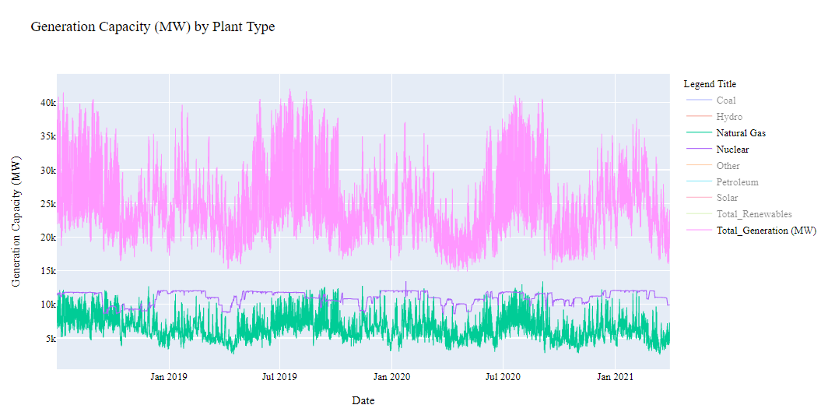

Correlations between power sources are shown in Figure 8. I dropped Petroleum from the correlation matrix because it had negligible contribution. Coal and natural gas behave most similarly to each other, while solar and nuclear are mostly uncorrelated with other power sources. However, hydro, solar, and other power sources make up only a small portion of total generation, seen in Figure 9.

Figure 8: Power generation correlation matrix

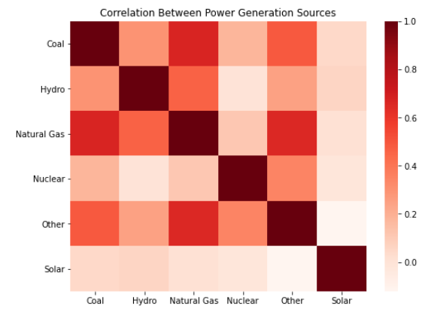

Figure 9: Percent Contribution to Total Power Generation

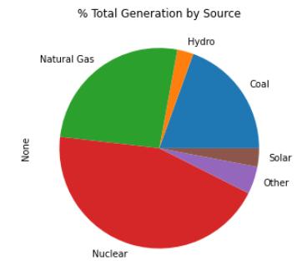

*Demand Data*

I began investigating the predictive power of ARIMA models on the demand time series by using the statsmodels package to plot autocorrelation and partial autocorrelation.

*Autoregressive component – Daily*

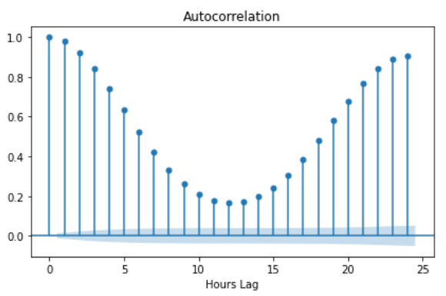

I first inspected over a 24-hour period. The ACF plot is in line with expectations. The power consumption during any hour is highly correlated with the previous hour, which would be explained by the inertia of aggregate daily activities across a population. The power consumption 24 hours away (during the same hour of the next day) is also highly correlated, because daily patterns tend to repeat. The lowest correlation is halfway through the day. This is unsurprising, because power consumption at noon should be significantly different than power consumption at midnight.

*Autoregression – Seasonal*

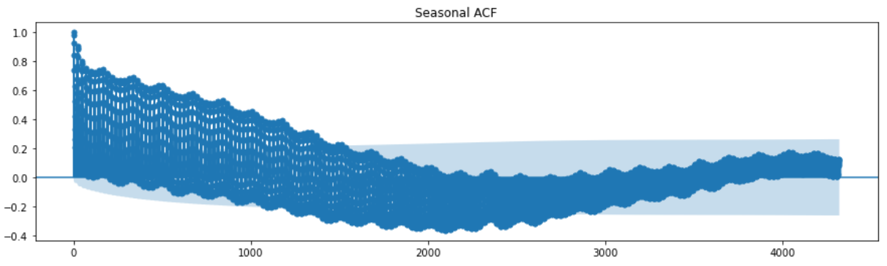

To see seasonal effects of autocorrelation, I plotted ACF over 180 days. The long-term ACF plot shows that the series becomes less correlated with the lagged version of itself as the lag approaches around 2000 hours. With 8760 hours per year, this is approximately a quarter of the way through a year, or the time between seasons.

*Moving Average*

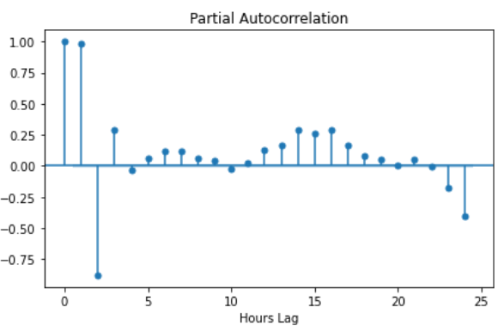

The moving average component of electricity demand is described by a partial autocorrelation function (PACF). This shows that an unexpected increase in electricity demand in the previous hour is predictive of continued increase two hours into the future. The third hour is inversely correlated with the 3-hour lag, and then beyond that, the moving average weakens as a predictor. I am not sure what mechanism is responsible for this, but may be caused by the length and profile of peak demand periods such as when people get home from work.

DATA COLLECTION and WRANGLING

*Generation and Demand Data*

I obtained electric power generation and demand data from EIA’s Hourly Electric Grid Monitor API. The data portal was in Beta testing when I began this project but moved into production on April 30th 2021. The generation data is provided by production source (such as coal, natural gas, or solar). The forecasted demand and actual demand are single-feature datasets representing the aggregate for the region.

<https://www.eia.gov/electricity/gridmonitor/dashboard/electric_overview/US48/US48>

*Weather Data*

Weather – specifically temperature – is expected to affect demand because of its influence on electric heating and cooling. The demand data is hourly, so I needed a data source with at least hourly resolution on historical temperatures. I used the NCEI (National Centers for Environmental Information) API to pull the data.

Balancing authorities do not know the exact temperatures 24 hours in advance and need to rely on local forecasts. I could not find a source a source for historical 24-hour forecasts, so I incorporated a random error into the historical measurements based on the average error in 1-day ahead forecasts described by Segarra et al (2019). (<https://doi.org/10.3390/en12071309>).

The region handled by the Carolinas balancing authority is shown in Figure 1. It is difficult to choose a single representative weather forecast because the region covers two states, and forecasts are for specific locations. I choose to use the average of forecasts for major cities in approximately the center of each state (Raleigh, NC and Columbia, SC).

Figure : Carolinas Balancing Authority Regin

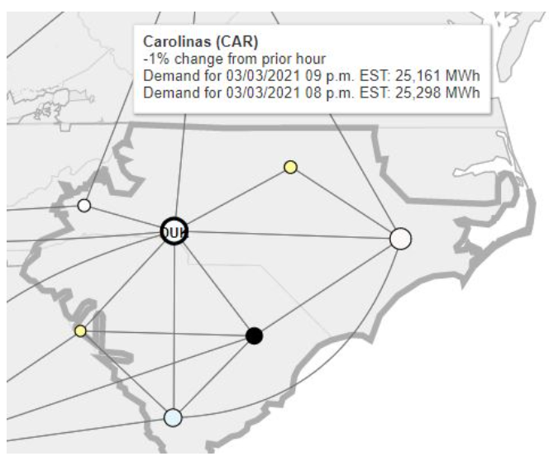

NCEI data included many variables including both wet bulb and dry bulb temperature. I selected dry bulb temperature instead of wet bulb (which incorporates the effect of humidity). A hybrid of dry bulb and wet bulb could possibly work better since air conditioning loads increase with higher humidity, but this is a potential topic for further research.

The main data cleaning required on weather data was dealing with non-numeric data containing an “s” and missing values represented by asterisks. The “s” indicates “suspected value” according to the documentation, so I replaced all occurrences of “s” with a blank string and then converted the column to the numeric data type. I addressed the missing values by replacing the asterisks with np.NaN and then backfilling with the pandas df.fillna() method.

Figure : Non-numerical values in weather data

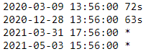

*Adjusting for temperature forecast accuracy*

The average mean-absolute error of the day-ahead temperature forecast is 1.39 degrees C, as assessed by Segarra et al (2019). Because the NCEI temperature measurements are at irregular intervals, the first step was to resample to 24-hour periods using the pandas resample(‘1D’) method. I converted the Celsius unit to Fahrenheit to match NCEI data and then used np.random.normal(), setting the scale parameter to the mean absolute error of their findings. This generated an array of temperature forecast errors.

These errors were again resampled to 1-hour intervals to line up with the EIA data. I forward filled a few missing values resulting from discrepancies in timeframes of the 1-day and 1-hour resamplings. I then added these errors to the average measured temperature between the two cities to create a simulated day-ahead forecast column.

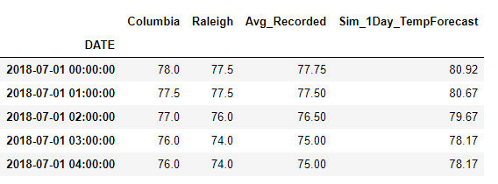

*Benchmark Forecasts*

The balancing authority 24-hour forecasts collected by EIA serves as a benchmark for assessing the results of the machine learning models. It is collected through a government survey form (EIA-930) that requests data in CSV or XML format. Figure 4 shows it contains some data errors visible as outliers.

Figure : EIA Demand Forecast Data

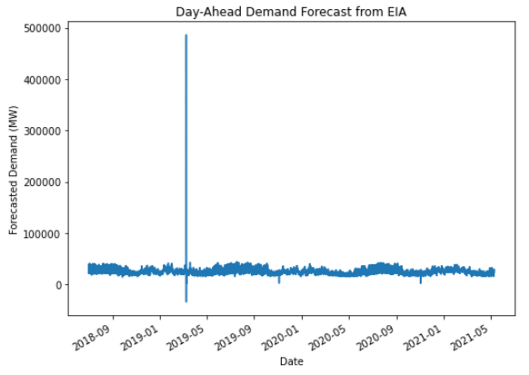

To filter out probable errors, I looked at the distribution of changes in forecasted demand over 1-hour intervals to detect any large spikes. Figure 5 shows that it is rare for the forecasted demand to be less than 0.85 of the previous hour or more than 1.15 of the previous hour. For any values that fell outside this range, I replaced them with the rolling median of the past 24 hours.

Figure : Histogram of change in forecasted demand from previous hour

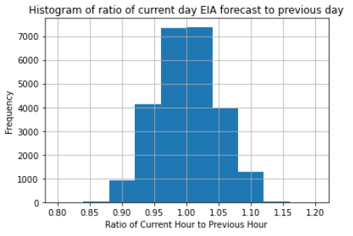

The error-filtered time series is shown in Figure 6. There is still a significant anomaly in April; however, it is less severe and using a tighter window for filtering errors may eliminate good data. Additionally, the machine learning model is not trained on this data and it is only for comparison.

Figure : EIA Demand Forecasts after Outlier Removal

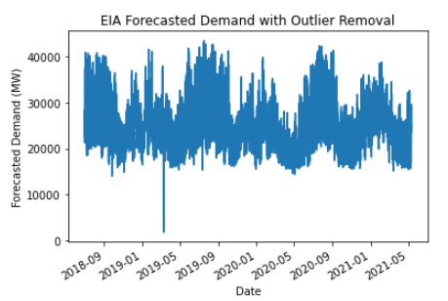

**MODELING AND TESTING**

**SARIMAX Model**

*Parameter Tuning*

Because of the size of the data set and number of tests required to validate the model, tuning the parameters is time consuming. The SARIMAX model contains the argument order=(p,d,q), where p = number of AR lags to include, d = integration order of the process (to make data stationary), and q = number of MA lags to include. From the EDA, the time series showed both AR and MA components, so these parameters must be specified.

I used the arma_order_select_ic method in the statsmodels package to autofit AR and MA parameters. Including too many lags can cause overfitting, and too few can lose precision. I chose the Bayesian Information Criterion (‘bic’) argument for the output reported, in which the number of parameters that result in the lowest BIC is generally best.

Figure 10 shows a heatmap of the different BIC values for different combinations of AR parameters. It appears that an AR of 4 and MA of 3 may be optimal. These values seem reasonable based on the ACF and PACF graphs, which showed that autocorrelation coefficient was above 0.8 for up to 4 lags, and that the PACF coefficient was high (in positive or negative direction) for up to 3 lags, with a sharp drop-off thereafter.

Figure : Heatmap of BIC values for ARMA parameters

